Assignment No-2B

Roll No-COTC11

1.SELECT

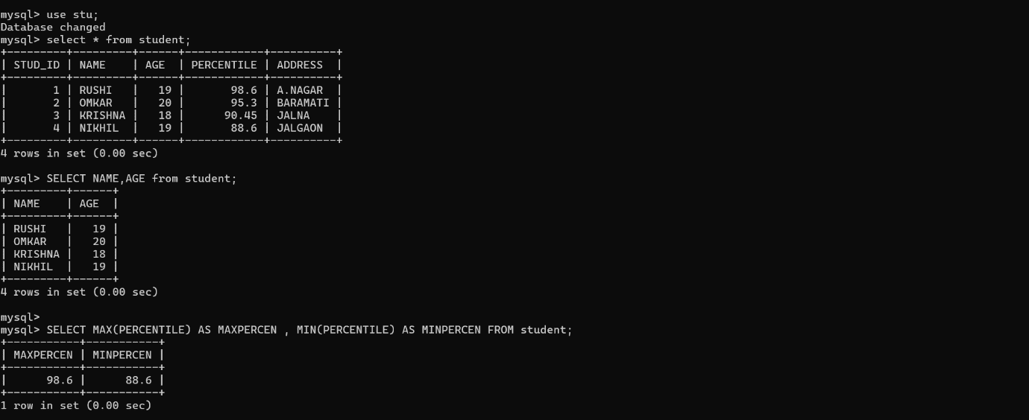

2.UPDATE

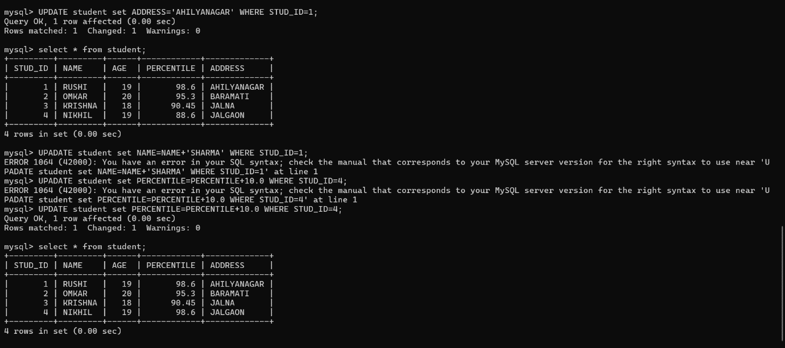

3.DELETE

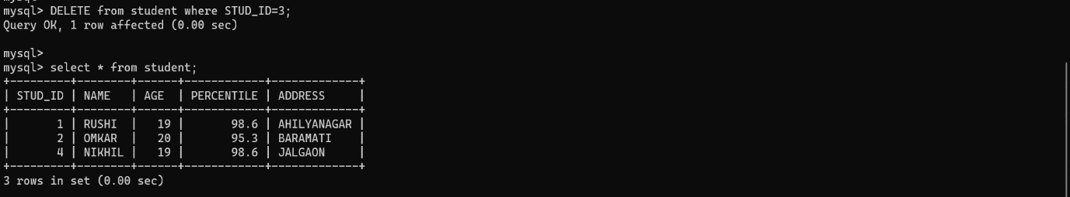

4.SET OPERATION (UNION AND INTERSECT)

